[Table_Main]
Research Report
30 Jan 2026
Howmet Aerospace (HWM US)
Aero-Engine Castings Leader, F-35 Sole Source + CAM Integration Widen Moat: Initiation
 |  | Howmet’s engine content strategy represents a "picks and shovels" play in the aerospace supply chain. Howmet Aerospace (NYSE: HWM) traces its roots to 1948 when it invented the first forged aluminum truck wheel and pioneered investment casting in 1951. Today the company operates four global segments: Engine Products (50% of 2024 sales) supplies castings, rings and airfoils for jet engines and industrial turbines; Fastening Systems (22%) holds the #1 global position in aerospace fasteners; Engineered Structures (14%) produces titanium mill products and multi-material airframe components; and Forged Wheels (14%) leads the global market in aluminum truck wheels. In 2025Q3, all segments again expanded their Segment Adjusted EBITDA Margin versus the same quarter of 2024, adding 0.8–5.1 percentage points and reaching new third-quarter highs. HWM provided its initial 2026 revenue outlook during its 2025Q3 earnings call, which is $9 billion, up 10% on year for 2026.  Sole F-35 Fan Disc Supplier, Long-Term OEM Partnerships Locked In. Howmet is the exclusive supplier of titanium fan discs for the F-35 Lightning II, the world's most advanced fighter with 191 jets delivered in 2025 and nearly 1,300 in global service. The company's components are embedded throughout the aircraft: forged aluminum bulkheads save 300-400 pounds per jet, titanium structures serve all three F-35 variants, nickel-based superalloy blades operate above metal melting points, and vibration-resistant fasteners endure extreme G-forces. Co-development agreements with Lockheed Martin, Boeing, Airbus and Rolls-Royce secure share on critical platforms, while top global rankings in titanium alloy 3D printing patents reinforce metallurgical barriers to entry. In the future, HWM is expected to benefit from the mass production of the F35 and the recovery of a global airline.  Acquiring CAM broadens the company's moat. In 2026 Howmet will acquire Consolidated Aerospace Manufacturing for $1.8 billion, adding precision fasteners, fluid fittings and latches from brands including Bristol Industries and Moeller. CAM hardware covers the 737 MAX, A350, F-35 and KC-46, with expected 2026 revenue of $485-495 million and EBITDA margins above 20% pre-synergies. The deal raises content per aircraft across virtually all major commercial and military platforms, while CAM Defense's work with Blue Origin, SpaceX and Stratolaunch extends Howmet's reach into rocket propulsion systems. It also enhances the one-stop service capabilities for core clients such as Boeing and Airbus.  Valuation& recommendation  We estimate that revenue of HWM from year 2025 to 2028 will be $8,188/9,106 /10,077/11,139 million, with the net profit of $1,408/1,711/1,883/2,190million. Based on the DCF valuation model, our target price of HWM is $234.72, we initiate coverage on the stock with “Outperform”.  Risks  Market Demand & Economic Sensitivity; Narrow and Wide-Body Aircraft Market Risks Constraints in the supply chain, including shortages of engine components and labor; The cost of acquiring and integrating CAM may exceed the budget, affecting EBITA; Labor Negotiations and Workforce Challenges.
  [Table_Info]
  Initiate with OUTPERFORM
  Rating | OUTPERFORM
  Current Price
  Target Price
  Market cap
  Shares in issue
  1 yr high - low
  Note: Current Price X is the close price on X Jan 2026
  Source: HFI
  [Table_Profit]
  US$ mn | Dec-24A |  | Dec-25E |  | Dec-26E |  | Dec-27E
  Revenue
  （+/-）
  Net profit
  （+/-）
  Diluted EPS (US$)
  GPM
  ROE
  P/E
  Source: Company data, HFI
[Table_Author]
Bin Yang, SFC:BSQ313
harryyang@hfisec.com.hk

Contents
1. Howmet Aerospace: A Company of Innovators and Makers 3
1.1 Global Aero-Engine Structural Castings Leader 3
1.2 Engine Products: Titanium Structural Components and Airfoils (Turbine Blades and Vanes) 7
1.3 Financial Performance 16
2. Core Competitive Strengths 21
2.1 Sole Supplier of F-35 Fan Discs 21
2.2 Deep Metallurgical Expertise & High-Performance Components 24
2.3 Robust Order Book & Acquire CAM 27
3. Industry Tailwinds & HWM Positioning 31
3.1 Solid Demand in Defense Aerospace 31
3.2 Advanced Manufacturing & Powering Deep Space exploration 33
4. Valuation& recommendation 34
5. Risks 36

1. Howmet Aerospace: A Company of Innovators and Makers

1.1 Global Aero-Engine Structural Castings Leader
Howmet Aerospace (NYSE: HWM) is an American manufacturing company that develops and produces advanced engineered metal products primarily for the aerospace, defense, and commercial transportation sectors. Headquartered in Pittsburgh, Pennsylvania, it specializes in components such as investment castings, forgings, fasteners, seamless rolled rings, and titanium structures used in jet engines, airframes, and industrial gas turbines.

The company was founded in 1907. HWM traces its origins to innovations in the mid-20th century, including the invention of the first forged aluminum truck wheel in 1948 and early advancements in investment casting processes starting around 1951. In 2016, Arconic Inc. was spun-off as an independent company from Alcoa Inc. Arconic Inc. was comprised of three segments. In April 2020, Arconic Inc.’s Global Rolled Products segment was spun-off into another independent company as Arconic Corporation. The remaining Engineered Components and Forging segments were retained as the current Company, renamed to Howmet Aerospace Inc. Its current form emerged in 2020 as a spin-off from Arconic.
Figure: HWM’s timeline
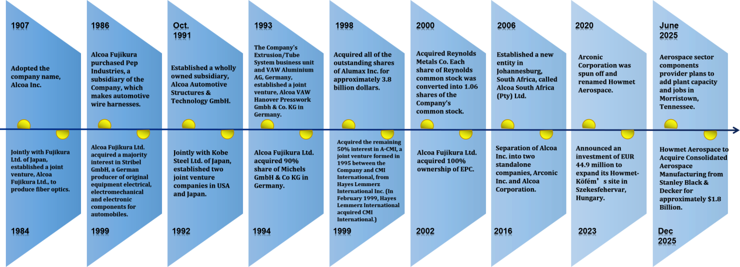
Source：marklines, recyclingtoday , HFI
HWM is a critical supplier, providing over 90% of structural and rotating aero engine parts for many aircraft manufacturers. Howmet’s operations consist of four worldwide reportable segments as follows:

Engine Products
Engine Products produces investment castings, including airfoils, and seamless rolled rings primarily for aircraft engines and industrial gas turbine applications. Engine Products produces rotating parts, as well as structural parts. As a world-class producer of aero engine and industrial gas turbine components, including airfoils, rings, disks and forgings. HWM excels in vacuum-melted superalloys, machining, performance coatings and hot isostatic pressing for high-performance parts.
Figure: HWM’s Engine Products - Manufacturer of high -performance aero engine and IGT components
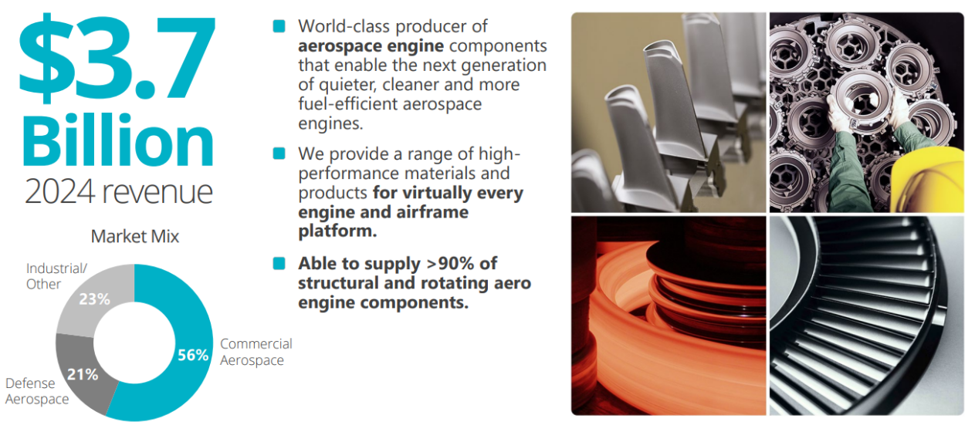
Source：Company Announcements , HFI
Fastening Systems
Fastening Systems produces aerospace fastening systems, as well as commercial transportation, industrial, and other fasteners. The business’s high-tech, multi-material fastening systems are found nose to tail on aircraft and aero engines. Fastening Systems’products are also critical components of commercial transportation vehicles and construction, industrial, and renewable energy equipment. HWM holds the number one global position in aerospace fastening systems, and we’re the North American leader in commercial transportation fasteners.
Figure: HWM’s Fastening System - Manufacturer of multi -material, engineered fastening products and systems
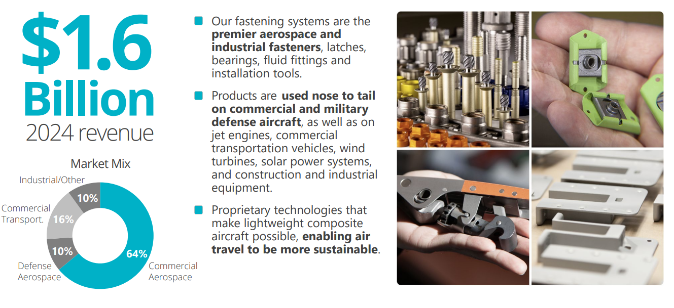
Source：Company Announcements , HFI

Engineered Structures
Engineered Structures produces titanium ingots and mill products for aerospace and defense applications and is vertically integrated to produce titanium forgings, titanium extrusions, forming and machining services for airframe, wing, aero-engine, and landing gear components. Engineered Structures also produces aluminum forgings, nickel forgings, and aluminum machined components and assemblies for aerospace and defense applications. As a world-class producer of titanium aero ingots and mill products – and a leader in highly engineered, multi-material structures for aircraft.
Figure: HWM’s Engineered Structures - Manufacturer of multi -material, engineered products and solutions
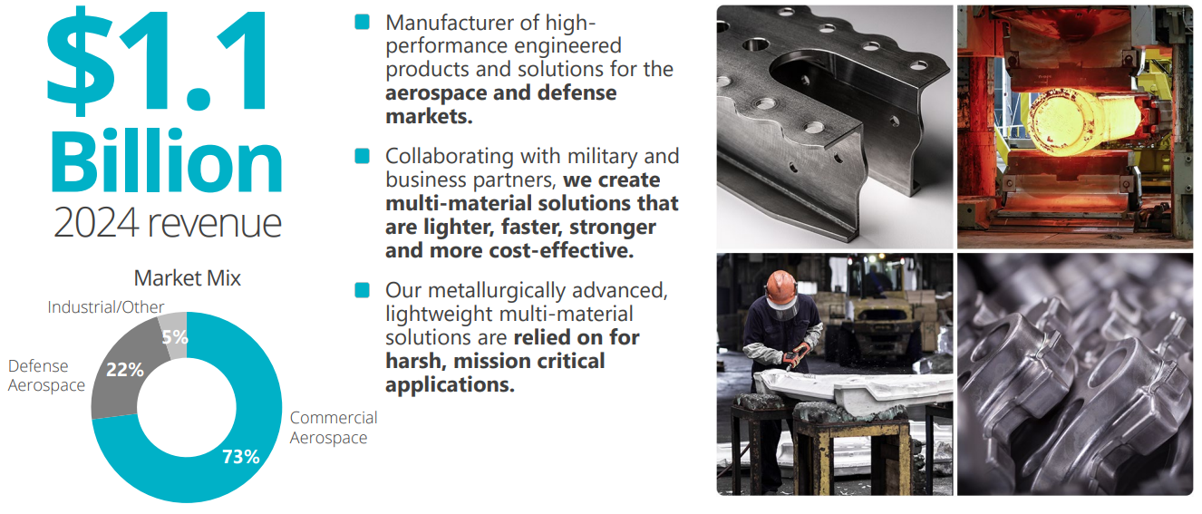
Source：Company Announcements , HFI

Forged Wheels
Company invented the first forged aluminum truck wheel in 1948 – and by doing so, they created an entire industry. Seven decades later, HWM is the number one global market leader in the forged, aluminum heavy-duty truck wheel market. Forged Wheels provides forged aluminum wheels and related products for heavy-duty trucks and the commercial transportation market.
Figure: HWM’s Forged Wheels - Manufacturer of forged aluminum wheels for commercial transportation
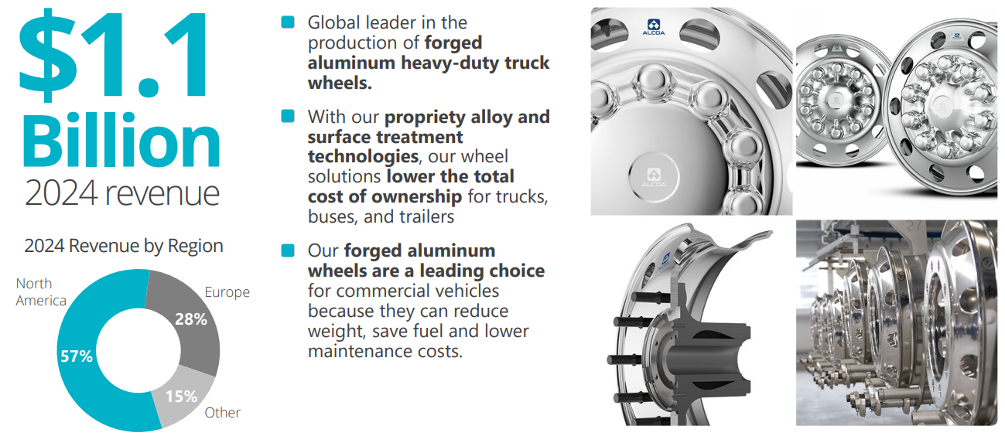
Source：Company Announcements , HFI

Figure: HWM’s operations consist of four worldwide reportable segments
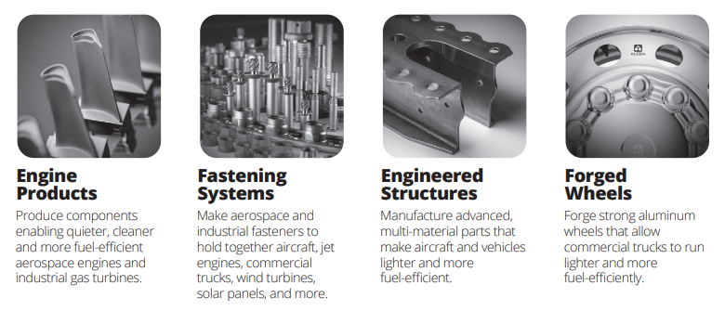
Source： Company Announcements , HFI

Figure: HWM’s four segments and select customers
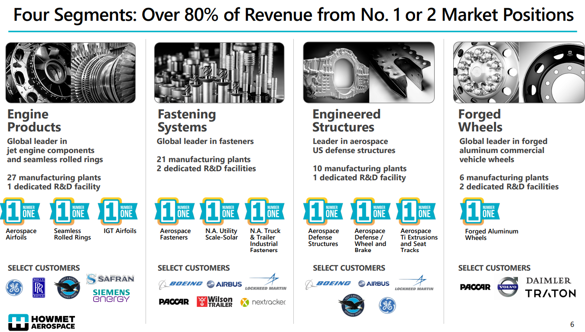
Source： Company Announcements , HFI

1.2 Engine Products: Titanium Structural Components and Airfoils (Turbine Blades and Vanes)
Howmet’s engine products portfolio spans the full thermo-mechanical spectrum—from titanium front frames and aluminum bleed valves in the cold section (lower operating temperatures, high strength-to-weight requirements) to single-crystal superalloy turbine airfoils and nickel-based mid/rear turbine frames in the hot section (extreme creep resistance and thermal management). Howmet’s engine content strategy represents a quintessential "picks and shovels" play in the aerospace supply chain. HWM embeds critical structural and hot-section content across virtually all commercial engine architectures.
Figure: HWM’s Key Engine Content
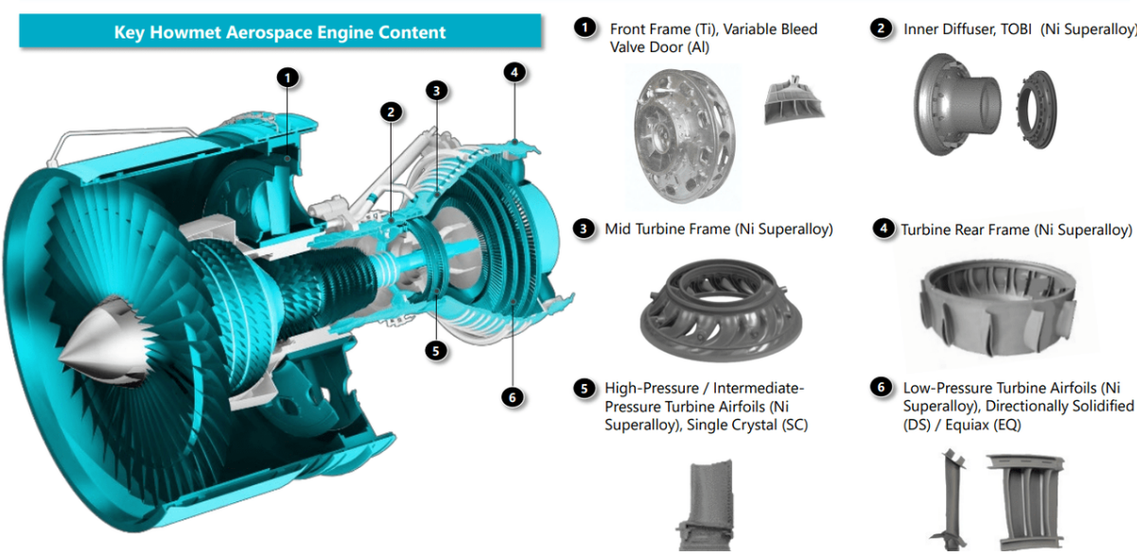
Source：Company Announcements , HFI
Howmet produces large, intricate investment casting made of titanium, including engine components and structural airframe parts. Howmet Engine Products Structural Castings & Components consist of primarily titanium alloys, nickel superalloys, and aluminum, designed for high-stress aerospace application. Key products include investment-cast titanium engine components (blades, vanes), airframe structures (frames, pylons), and fasteners designed for extreme heat and strength.

Figure: Engine Content Ubiquity-Full-Spectrum Coverage from Fan Cases to Turbine Airfoils
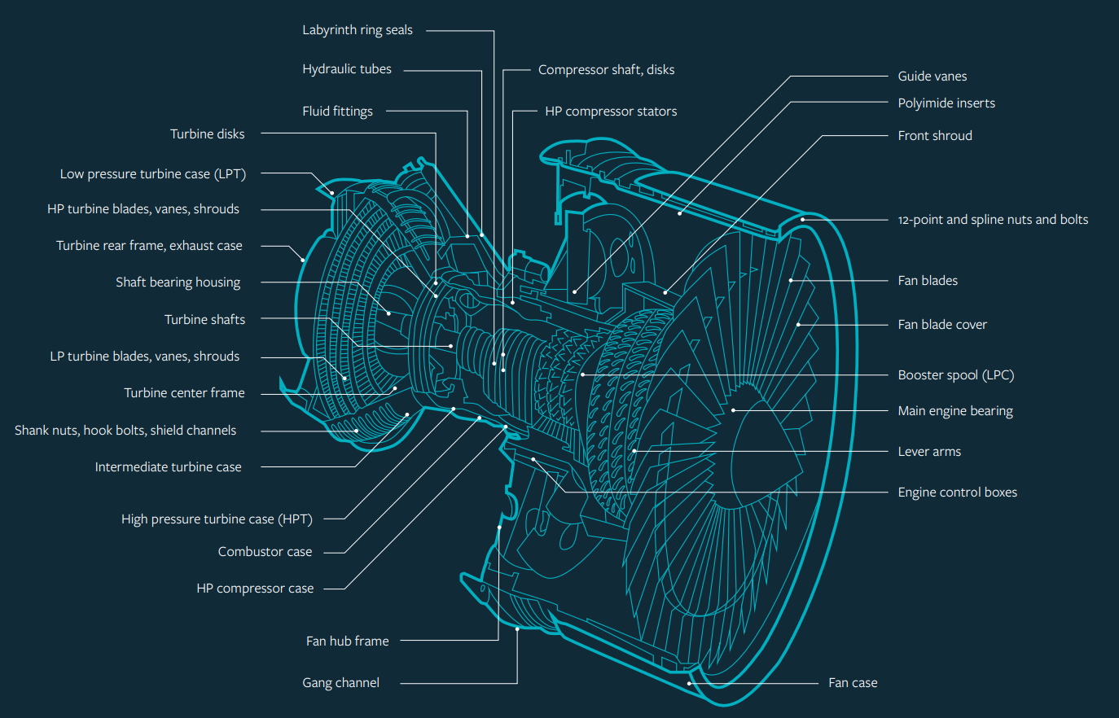
Source：Company Announcements , HFI *Howmet's Engine Products business inherited the complete technical lineage of Arconic's former aerospace division.

With the rapid development of aviation manufacturing industry in recent years, large-scale precision titanium alloy castings are more and more favored by designers due to their high overall size accuracy, good stiffness, light weight and high stability. For example, In the bell Boeing V-22 helicopter drive system, Howmet and Bell Helicopter replaced the components made of 43 aluminum alloy forgings and 536 fasteners with 3 titanium alloy integral precision castings and 32 fasteners, greatly reducing the quality of components, reducing the manufacturing cost by 30% and the manufacturing cycle by 62%. The U.S. F-22 fighter uses a large number of titanium alloy precision castings in the vertical tail rudder actuator support and other key bearing parts, accounting for about 7.1% of its overall structural quality.

Figure: Howmet's Titanium Monolithic Technology
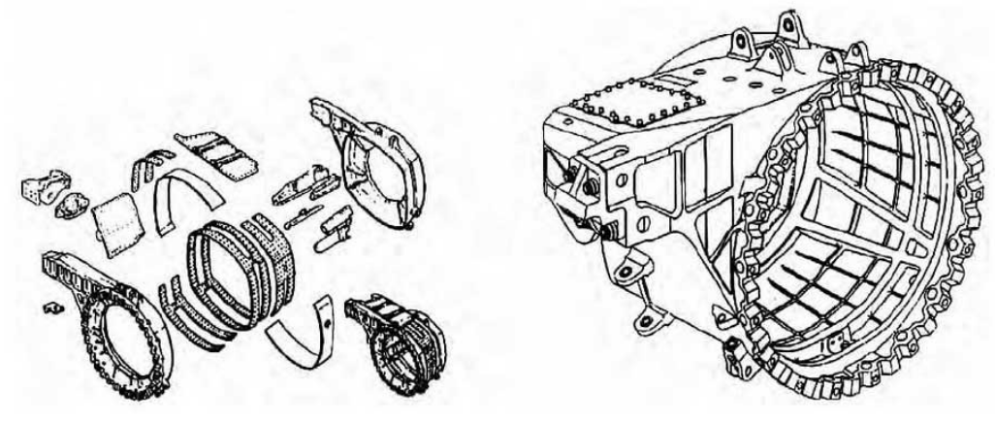
Source：zhycasting , HFI
Howmet’s titanium segment operates as a vertically integrated platform spanning the full metallurgical chain from revert recycling to finished parts. Through the TITAL acquisition and 3D-printed PMMA pattern technology, the company produces complex structural castings for airframes and engines, while manufacturing over 16,000 extruded profiles annually and market-leading fastening systems (LHP™ lockbolts). This closed-loop ecosystem—encompassing VAR remelting, advanced alloy development, and additive manufacturing—ensures stringent cost and quality control, creating a technical moat that single-process competitors cannot easily replicate.
Figure: Key technologies and capabilities of HWM Titanium Components
Key Titanium Components | Details
Advanced Titanium Casting | Through its TITAL acquisition, Howmet produces titanium structural components for airframes and engines, using 3D-printed PMMA patterns to create high-precision, complex shapes.
Titanium Fastening Systems | The company is a leader in titanium fasteners, offering products like LHP™ lockbolts for composite materials and Aero-Lite® pins, which provide high clamp loads and reduce aircraft weight.
Titanium Extrusion | The company utilizes advanced extrusion presses to produce over 16,000 solid and hollow titanium profiles per year.
Advanced Alloy Development | Development of advanced titanium alloys designed for higher-temperature aerospace applications.
Vertical Integration | Capabilities span from melting titanium to producing, forging, and machining finished, high-performance parts.
Additive Manufacturing (3D Printing) | Howmet is a leader in titanium alloy 3D printing for aerospace, focusing on complex structural components and engine parts.
Precision Casting & Forging | The company utilizes advanced techniques such as cold hearth melting, vacuum-arc remelting (VAR), and centrifugal/gravity casting to create titanium components, including near-net-shape parts that reduce waste.
Supply Chain Integration | Operations include the full cycle from raw material processing and revert (recycled titanium) to final ingot melting and testing.
Fastening Systems | Over 50 years of experience producing high-strength titanium fasteners for extreme temperature and stress applications.

Source： Company Announcements , HFI
Howmet Aerospace is a leader in turbine blade technology, pioneering single-crystal airfoils that offer up to nine times greater creep resistance, significantly increasing jet engine efficiency and lifespan. Their breakthroughs include advanced ceramic cores for cooling channels, high-temperature coatings, and proprietary aluminum-lithium fan blades. These innovations enhance thermal resistance and reduce weight, supporting next-generation, fuel-efficient aerospace engines.

Figure: Key Breakthroughs and Technologies of Howmet’s Turbine Blade
Turbine Blade breakthroughs | Details
Single-Crystal Airfoils | Perfected techniques for producing single-crystal, directionally solidified turbine blades that eliminate grain boundaries, improving resistance to deformation and high temperatures.
Advanced Internal Cooling | Engineered ceramic cores to create complex, hollow passages within airfoils, allowing increased air flow for cooling, essential for operating above the melting point of the base metal.
Next-Gen Materials & Coatings | Developed specialized superalloys and environmental coatings that protect components from extreme heat and pressure.
Aluminum-Lithium Fan Blades | Developed the first aluminum-lithium front fan blades for improved engine efficiency.
Manufacturing Excellence | As a dominant supplier for engines like the LEAP, Howmet is crucial for supplying high-pressure turbine blades, despite current production challenges in meeting industry demand.
Extending Service Life | Up to 25,000 hours between overhauls

Source： Company Announcements , HFI
Howmet carries forward the technical legacy of Arconic's aero-engine division, maintaining global market leadership in seamless rings, fastening systems, and single-crystal airfoils.
engineers, backed by decades of materials science expertise and working closely with leading aero engine manufacturers, enable:

- Advanced single crystal turbine airfoils with specifically aligned grain structures, which increase turbine blade life, temperature capability and strength.
- Engineered ceramics that allow turbine airfoil designers to create intricate internal turbine blade cooling schemes that improve efficiency and lengthen the life of the blade.
- Advanced coatings that protect the engine airfoils from the extreme combustion temperatures of today’s gas turbines.
Figure: Technology Moat - Cooling, Coatings, and Digital Manufacturing
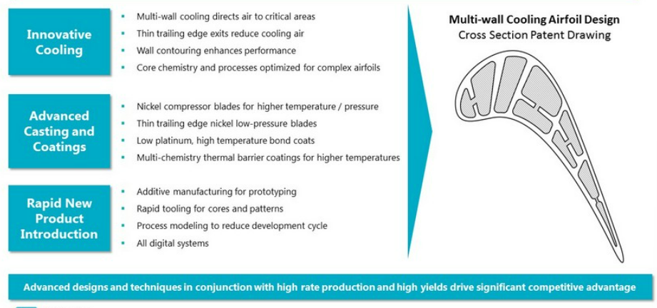
Source： Company Announcements , HFI
Single-Crystal Blades: Combustor temperatures reach 1,600–2,000°C—far exceeding the blade alloy's melting point (1,000–1,200°C). Howmet's solution is a triple-layer thermal shield plus a single-crystal substrate: surface film cooling drops temps by 500°C, ceramic coatings add another 300°C of insulation, and a patented platinum-aluminum-hafnium (Pt-Al-Hf) bondcoat extends service life by 3–5×.

The real moat is in the casting. Howmet casts 200-micron (hair-thin) internal cooling channels in one shot—no post-cast drilling required. This "drill-free" technology preserves material integrity while making the intricate internal geometry impossible to reverse-engineer, creating the ultimate defensive barrier in the hot-section components market.

Figure: Technical Barriers of Howmet's Single-Crystal Turbine Blades
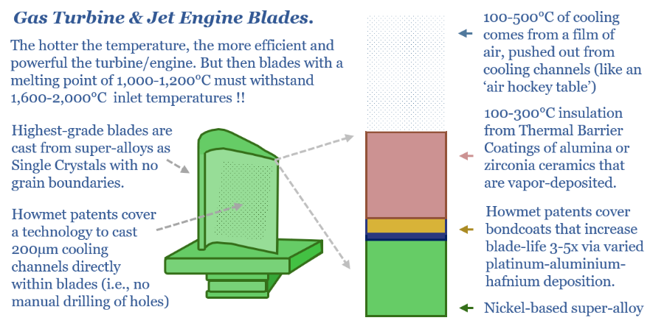
Source： thundersaidenergy , HFI

Figure: Blade Cross-Section Structure (From Right Image, Top to Bottom)
Layer | Material/Technology | Function | Howmet Patent Moat
Film Cooling | Air Film | Blows cool air from surface micro-holes forming an "air cushion," reducing temperature by 100-500°C | Direct casting of 200-micron cooling channels (drill-free)
Thermal Barrier Coating (TBC) | Alumina/Zirconia Ceramics | Vapor-deposited, provides 100-300°C thermal insulation | Proprietary ceramic formulation & EB-PVD deposition process
Bondcoat | Platinum-Aluminum-Hafnium (Pt-Al-Hf) | Bonds substrate to coating, oxidation/corrosion resistant; extends blade life by 3-5× | Patented Pt-Al-Hf deposition composition
Substrate | Nickel-based Single-Crystal Superalloy | Grain-boundary-free structure, primary load-bearing component | Single-crystal directional solidification casting technology

Source： thundersaidenergy , HFI

OEMs like Pratt & Whitney, GE Aerospace, Rolls Royce, and Safran are pushing toward higher bypass ratios and hotter cores for better fuel burn and lower emissions. That only works if the materials can cope. Howmet Aerospace is effectively a key enabler of more efficient, lower emission aviation without needing a radical change in propulsion architecture.

In jet engine and industrial gas turbine castings, the clearest head to head rivalry is between Howmet Aerospace and Precision Castparts, a Berkshire Hathaway company. PCC’s portfolio includes products like PCC Airfoils turbine blades and Special Metals superalloy materials, which compete directly with Howmet Aerospace’s Engine Products division.
Compared directly to PCC Airfoils, Howmet Aerospace’s engine components emphasize:
- Process innovation in single crystal and directionally solidified casting, driven by deep collaboration with engine OEMs.
- Integration with downstream machining and coatings, bundling more value into each component.
- Portfolio diversification into defense and industrial markets, spreading risk beyond a single large customer set.

In 2015, Berkshire acquired Precision Castparts (PCC) for $37bn. Over the last decade, PCCs revenue and operating income has declined from $10bn to ~$9.5bn and $2.5bn to $1.5bn, respectively. What was once an investment casting duopoly has now seen entrants such as Consolidated Precision Products (CPP) take share.

Comparing the Single Crystal HPT Blade Investment Casting Process of Howmet and Precision Castparts, it is a difficult craft. There are literally only four or five companies in the world that are any good at it. PCC and Howmet probably own 80% of the market, maybe even higher for single crystal.

The aircraft engine blade market has witnessed notable growth in recent years and is poised for further expansion. Valued at $17.52 billion in 2025, the market is projected to reach $18.84 billion in 2026, growing at a CAGR of 7.5%. Looking ahead, the market is expected to continue its upward trajectory, reaching $24.92 billion by 2030 at a CAGR of 7.2%.

According to Research and Markets, the global aircraft engine blade market was valued at approximately $17.52 billion in 2025. Excluding composite fan blades, the addressable market for investment castings is estimated at $8-9 billion. Within this, single-crystal and directionally-solidified (DS) high-temperature blades represent approximately $5-6 billion, where Howmet and PCC form a duopoly with a combined market share of approximately 75-85% (equivalent to$4-5 billion).

Figure: Aircraft Engine Blade Market Predict
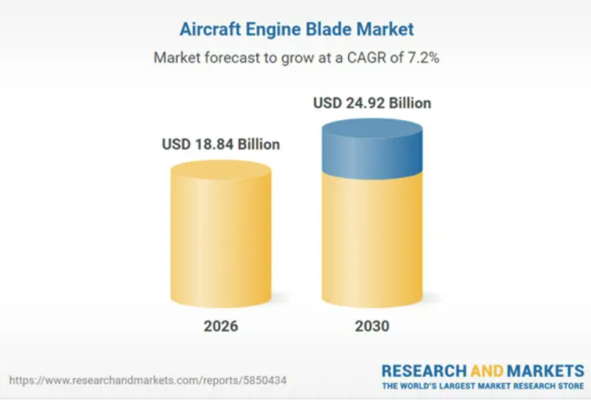
Source: GlobeNewswires, HFI

As a tier-1 component supplier, Howmet operates with materially lower R&D intensity (0.54%) versus integrated engine manufacturers GE and Safran (7% and 7.84%) in 2024. Similarly, HWM maintains a significantly leaner workforce (23930 employees) compared to GE (53000) and Safran (99364) in 2024, underscoring its asset-light, specialized supplier model versus the vertically integrated operations of full-service engine OEMs.

Figure: R&D Expense Ratio Comparison (2022-2024) |  | Figure: Total Employment Comparison (2022-2024)
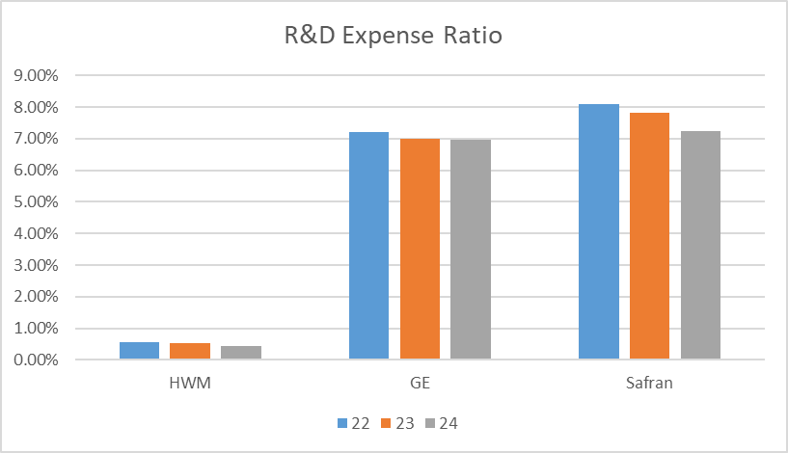 |  | 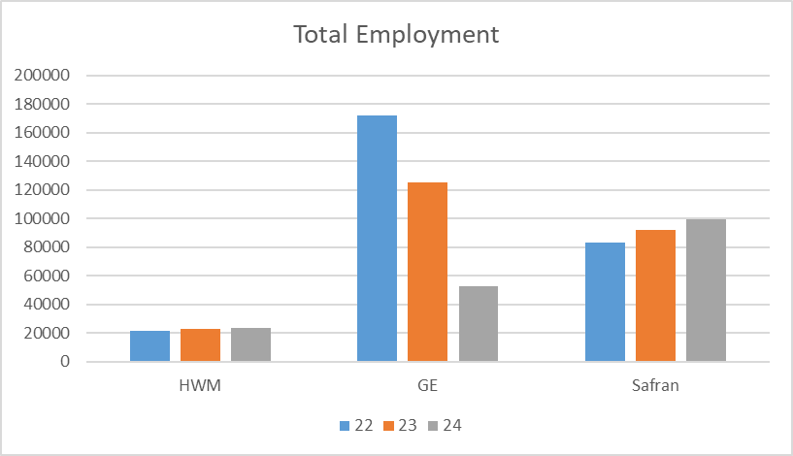
Source: Company Announcements, HFI |  | Source: Company Announcements, HFI
In 2024, Howmet holds 950 granted patents and 220 pending applications, enjoying 20-year protection terms from filing dates under USPTO standards. The portfolio exhibits temporal bifurcation: legacy patents inherited from the 2016 Arconic spin-off retain <12 years of remaining validity, while post-2016 filings enjoy 15-20 years of protection. HWM discloses that its business is not materially dependent on any single patent. Material formulations and thermal treatment processes—are protected as trade secrets, which are not subject to the 20-year statutory limit and can be maintained indefinitely.
Figure: HWM’s Worldwide patents (2021-2024)
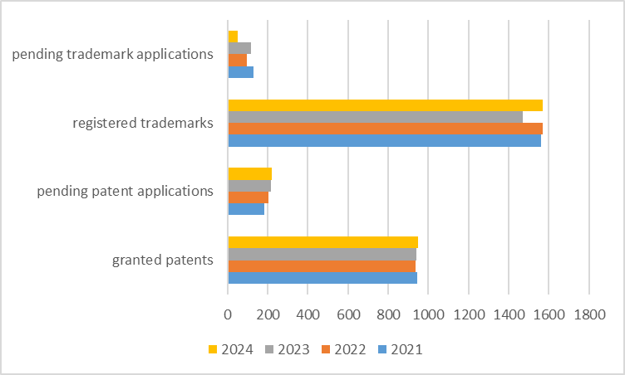
Source: Company Announcements, HFI

1.3 Financial Performance
In 2024, Howmet Aerospace generated revenue of $7.4 billion, up 12% year-on-year, primarily driven by growth in the commercial aerospace market of 20%. Engine Products (50% share) rose 14% on robust demand from commercial and defense aerospace as well as industrial gas turbines, while Fastening Systems (22%) and Engineered Structures (14%) increased 17% and 21%, respectively, buoyed by the commercial-aerospace rebound—particularly wide-body recovery—and defense aerospace markets. Only Forged Wheels (14%) declined 8% amid weaker commercial-transportation volumes and reduced pass-through of aluminum and other inflationary costs. Geographically, the Americas remained the largest market at 56% of full-year sales, Europe contributed 33% on the back of Airbus production gains, and Asia-Pacific represented 14%.

Figure: HWM’s 2024 Revenue by Segment & Sales by Regional Destination
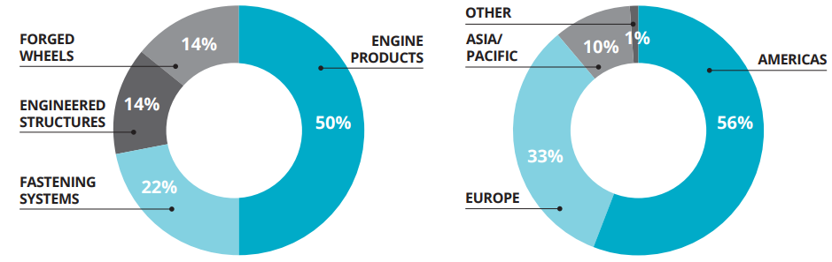
Source: Company Announcements, HFI

Record EBITDA margins. In 2025Q3, Engine Products delivered Segment Adjusted EBITDA of $368 million, up 19.9 % YoY, extending the quarterly uptrend that began in 2021, supported by simultaneous expansion in commercial aerospace, defense aerospace, industrial gas turbines and oil-&-gas markets.

Fastening Systems reached $138 million, surging 35.3 % YoY—its fastest quarterly pace in four years—benefiting from recovering commercial-aerospace demand and productivity gains that largely offset weakness in commercial transportation; the segment’s EBITDA has nearly doubled since 2021.

Engineered Structures hit $58 million, jumping 52.6 % YoY and setting a new quarterly record, driven by combined momentum in defense and commercial aerospace, the steepest recovery slope among the four divisions.

Forged Wheels recorded $73 million, up 14.1 % YoY, with the gain achieved primarily through cost-reduction initiatives in response to lower commercial-transportation volumes; EBITDA for this segment declined 2 % between 2021 and 2024 Q3, signalling a defensive posture.

Collectively, the three segments (Engine Products, Fastening Systems and Engineered Structures) grew EBITDA more than 70 % versus 2021 Q3 and raised their share of total segment EBITDA from 75 % to 87 %, further concentrating profitability in the highest-growth markets.

Figure: HWM’s 2021-2025Q3 Segment Adjusted EBITDA by Segment (in U.S. dollar millions)
 | 2021 | 2022 | 2023 | 2024 | 2024Q3 | 2025Q3 | YOY
Engine Products | 564 | 729 | 887 | 1150 | 307 | 368 | 19.87%
Fastening Systems | 239 | 234 | 278 | 406 | 102 | 138 | 35.29%
Engineered Structures | 103 | 111 | 113 | 166 | 38 | 58 | 52.63%
Forged Wheels | 294 | 278 | 309 | 287 | 64 | 73 | 14.06%

Source: Company Announcements, HFI

In 2025Q3, all segments again expanded their Segment Adjusted EBITDA Margin versus the same quarter of 2024, adding 0.8–5.1 percentage points and reaching new third-quarter highs. Looking at full-year trends from 2021 to 2024, Engine Products rose from 24.7% to 30.8%, Fastening Systems climbed from 22.9% to 25.8%, Engineered Structures recovered from 14.2% to 15.6%, and Forged Wheels rebounded to 27.2%. The upward pattern is consistent across both quarterly and annual data, signalling durable profitability improvement.

Figure: HWM’s 2021-2025Q3 Segment Adjusted EBITDA Margin by Segment
 | 2021 | 2022 | 2023 | 2024 | 2024Q3 | 2025Q3
Engine Products | 24.7% | 27.0% | 27.2% | 30.8% | 32.5% | 33.3%
Fastening Systems | 22.9% | 20.9% | 20.6% | 25.8% | 26.0% | 30.8%
Engineered Structures | 14.2% | 14.1% | 12.9% | 15.6% | 15.0% | 20.1%
Forged Wheels | 31.9% | 26.3% | 26.9% | 27.2% | 26.1% | 29.6%

Source: Company Announcements, HFI

Robust Free Cash Flow Growth Fuels Accelerated Shareholder Returns. In 2025Q3, HWM’s Free Cash Flow was $423 million after $108 million of capital expenditures, bringing the 2025 year-to-date total to $901 million, up 50.4 % from $599 million in 2024Q1-Q3. Strong cash generation supported continued return of cash to shareholders, with $200 million of share repurchases in the third quarter 2025 and an additional $100 million in October, bringing year-to-date repurchases to $600 million. Furthermore, the Board of Directors declared a 20% increase in the common stock dividend to $0.12 per share in the third quarter 2025.

Figure: HWM’s 2021-2025Q1-Q3 Adjusted free cash flow
Source: Company Announcements, HFI

HWM’s 2025Q3 results described as beating across the board, stronger guidance. Howmet raised its full-year 2025 revenue guidance from baseline $8.13 billion to baseline $8.185 billion, profit forecast on strong aircraft demand. Also, HWM provided its initial 2026 revenue outlook during its 2025Q3 earnings call, which is $9 billion, up 10% on year for 2026 supported by rising production rates, engine spares, and industrial gas turbine demand linked to data centers.

Boeing and Airbus are ramping up production of their strong-selling single-aisle jets, fueled by long order books and resilient air travel demand, benefiting suppliers like Howmet. At the same time, supply chain challenges and delays on output of widebody jets have weighed on new plane production, keeping older aircraft that require spare parts flying longer.
Figure: HWM’s 2025 Guidance and 2026 Revenue Guidance (By 2025Q3)
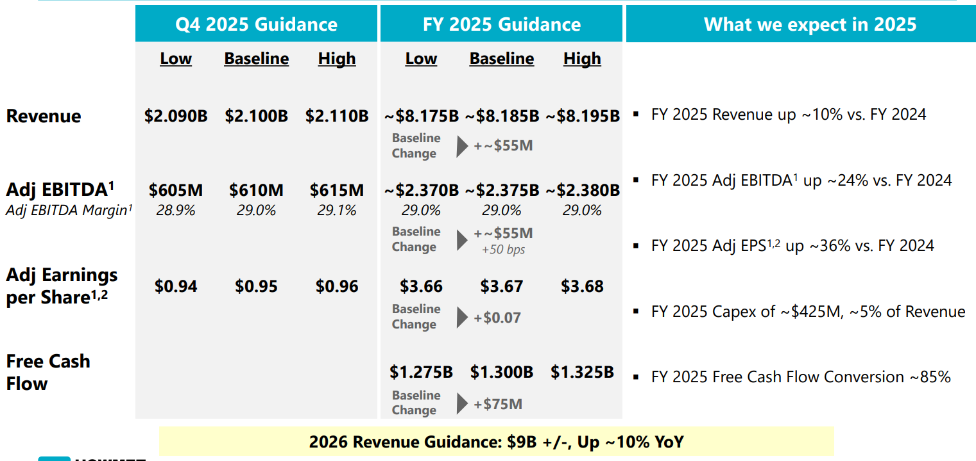
Source： Company Announcements , HFI

Figure: HWM expected Each Debt Tower Below Annual Free Cash Flow Expectations
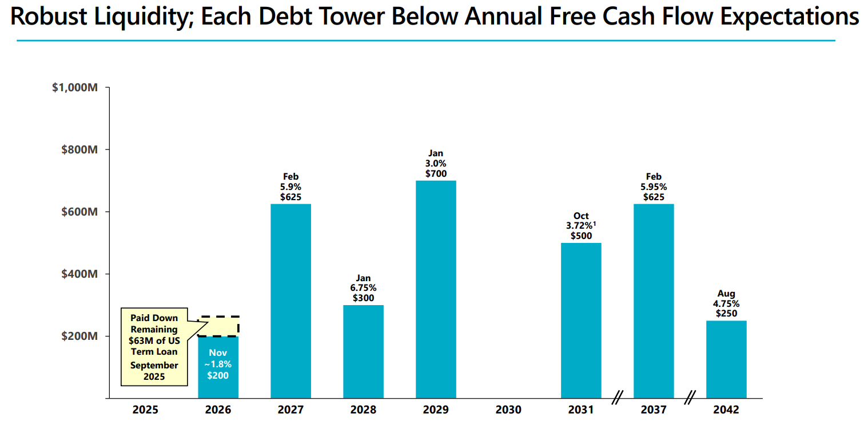
Source： Company Announcements , HFI

Industry PPI for aircraft engine manufacturing has risen cumulatively by 17.88% since 2020 (from233.3 to 275.01), with the engine parts sub-index exhibiting a steeper climb, reflecting persistent cost inflation across aerospace supply chains. Leveraging proprietary technology moats, HWM maintains pricing power through cost pass‐via price escalation clauses embedded in Long‐Term Agreements. The continued uptrend in PPI since late 2024 (lower panels) further validates the defensive support of HWM’s technology premium on gross margins amid industry‐wide pricing pressure.
Figure: Producer Price Index by Industry – Aircraft Engine and Engine Parts Manufacturing (Jul2020-Jul2025)
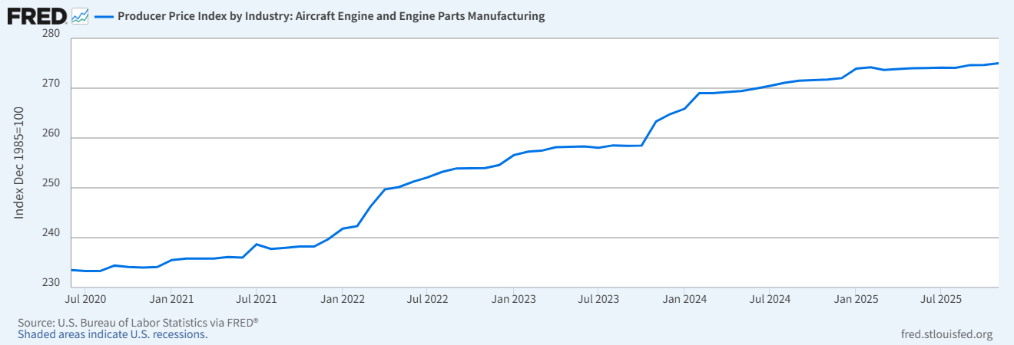
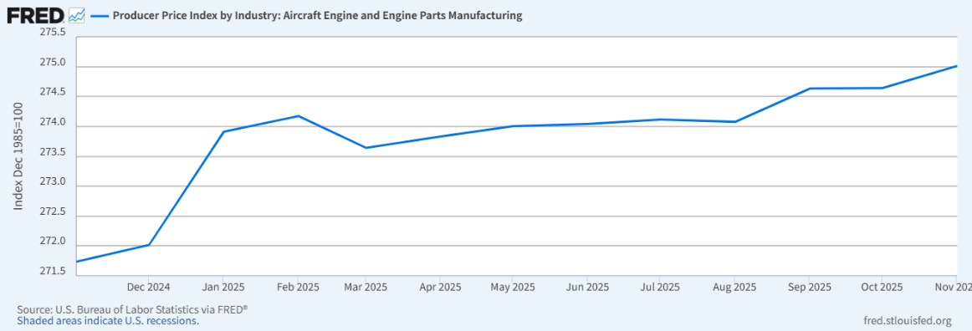
Source：Fred , HFI

Figure: Producer Price Index by Industry – Aircraft Engine and Engine Parts Manufacturing-Accessories (Jul2020-Jul2025)
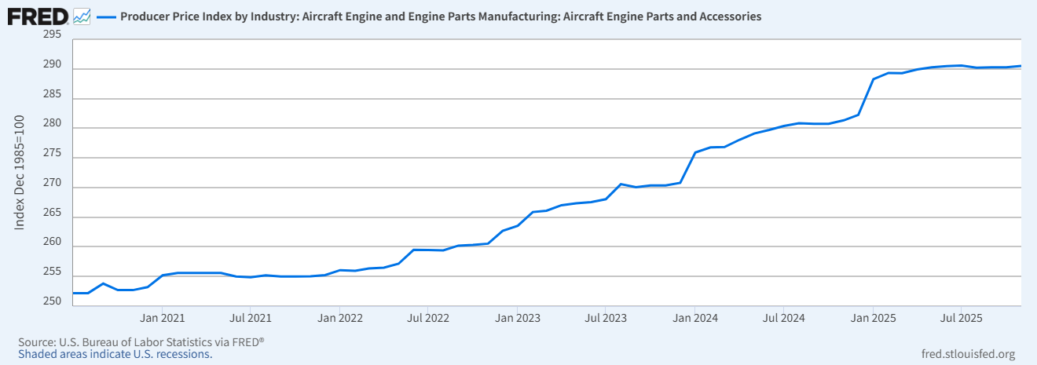
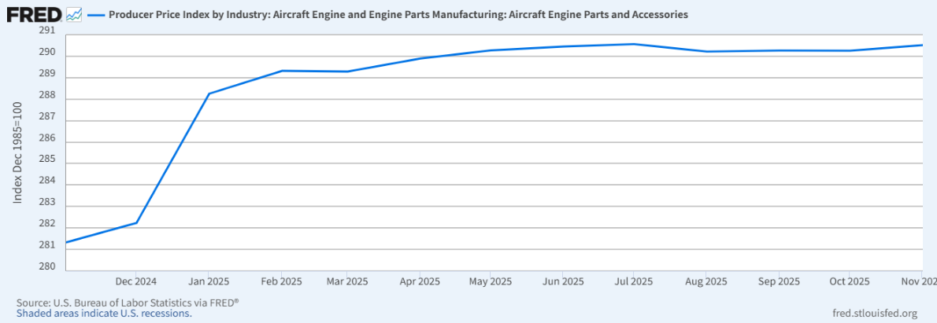
Source：Fred , HFI

2. Core Competitive Strengths

2.1 Sole Supplier of F-35 Fan Discs
Currently, the defense aerospace market remains strong across F-35 demand in addition to legacy fighters. The Lockheed Martin F-35 Lightning II is one of the most sophisticated defense aircraft ever to take flight—and Howmet Aerospace innovation helps make it soar.

From nose to tail, Howmet Aerospace solutions help meet aggressive weight, range and fuel efficiency targets and enable the F-35 to do what other military aircraft can’t.

Engineering the unprecedented. In developing this complex machine, Lockheed Martin turned to Howmet Aerospace for many of its critical parts. These include single-piece forged aluminum bulkheads that form the “backbone” of the aircraft structure and save 300 to 400 pounds per jet and up to 20 percent in costs. Howmet also supply titanium bulkheads and the titanium material used to manufacture other airframe structures for all three F-35 JSF variants.

To propel the powerful engine, Howmet supply single-crystal, nickel-based superalloy blades and vanes that operate in environments hotter than the melting point of the metal. And their seamless rolled rings encase the engine parts.

To hold together the complex design, Howmet’s vibration-resistant fasteners are engineered to endure the most extreme G-forces and performance requirements.

Howmet supplies titanium ingot, billet, sheet and plate (the “Products”) to Lockheed Martin and other customers that also serve as suppliers to Lockheed Martin. The Products are made by mixing titanium sponge and titanium scrap metal that is reverted back to Howmet by its Customers to recycle into new Product.

Figure: The Lockheed Martin F-35 Lightning II
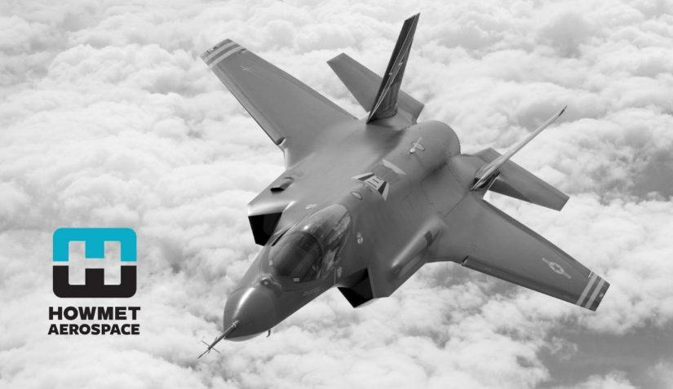
Source: Company Announcements, HFI

About the F-35. With 12 nations operating the F-35 across the global fleet, and almost 1,300 aircraft in service, the F-35 is delivering on its promise of unmatched reliability and lethality. Lockheed Martin is positioned to keep the fleet at the cutting edge of technology and support our allies as they expand their capabilities worldwide to ensure the F-35 remains an indispensable contributor to global security for decades to come.

Figure: F-35 Lightning II Technical data
Technical data
Wing Span | 10,70 m – 35 ft
Length | 15,70 m – 51.4 ft
Maximum Speed | Mach 1.6
Weapons Payload | 8,160 kg - 18,000 lb
Powerplant | Pratt & Whitney F135-PW-100 reheated turbofan
Thrust | 191 kN – 40,000 lb

Source: Leonardo, HFI

Annual F-35 production is now running at a pace five times faster than any other allied fighter currently in production, underscoring the program's scale and maturity. In a record-breaking year for the F-35 Lightning II program, Lockheed Martin delivered 191 F-35s in 2025, surpassing the previous delivery record of 142 jets. The milestone comes on the heels of the program reaching one million flight hours earlier in the year. In 2025, the program team also delivered the most advanced software to date with the completion of TR-3, as they sustained the global fleet of almost 1,300 aircraft and growing. Most importantly, the F-35 continued to prove its performance in real-world combat operations. Also, A new $24.3 billion contract was secured for 296 fighters, with international partners like Italy and Denmark adding 25 and 16 aircraft to their orders, respectively.

Figure: F-35 Total Deliveries
Source: Air Force Technology, HFI

Figure: F-35 Components and Howmet’s critical part
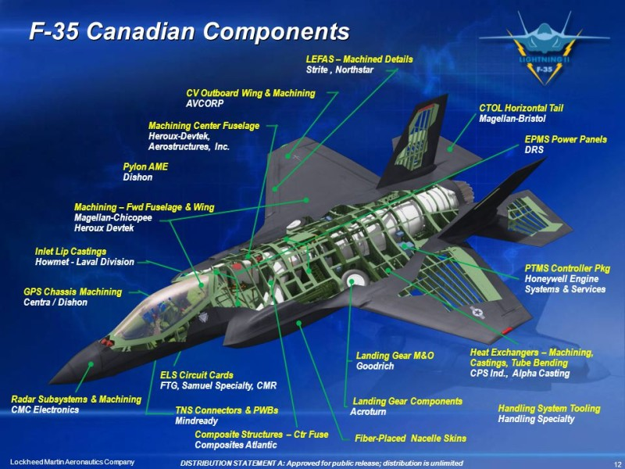
Source： Company Announcements , HFI

Howmet holds sole-source supplier status for titanium and aluminum bulkheads on the F-35 Joint Strike Fighter (JSF) program—arguably the most critical structural component in the airframe. This exclusive position (denoted as 'sole-source' in the diagram) creates an impenetrable moat: once qualified for a defense platform, switching costs and security clearances prevent competitor entry, securing multi-decade revenue visibility across the aircraft's 30+ year service life.

Howmet’s products are essential to the F-35 fighter jet, lighter aircraft with >50% carbon fiber use 2-3x higher-value fasteners, Howmet’s largest Forging Press is 50,000 tons and 10 stories tall, while Howmet is also the largest producer of forged aluminium wheels that are 45% lighter than steel, improving fuel efficiency by 5% and/or 3% greater payload capacity on 18-wheeler trucks.
Figure: Howmet F-35 Sole-Source-Titanium & Aluminum Bulkheads
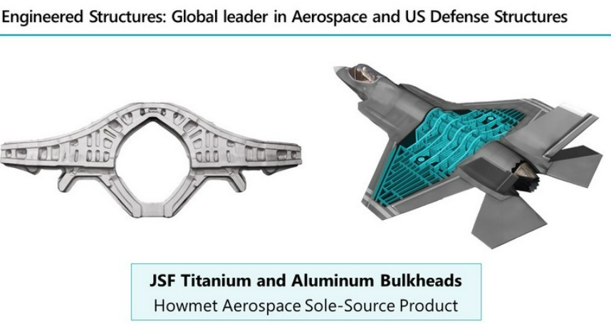
Source： Company Announcements , HFI

Growing global demand. Customers displayed continued confidence in the F-35 as they expanded their fleet size, with Italy and Denmark increasing their programs of record by adding 25 and 16 aircraft to their fleets, respectively. And across the program, international customers met major program milestones:

- Finland celebrated the rollout of its first F-35.

- Belgium welcomed its first in-country aircraft.

- Norway completed deliveries of its F-35 fleet.

In September, the F-35 Joint Program Office (JPO) and Lockheed Martin reached final agreement of Lots 18-19 for the production and delivery of up to 296 F-35s for $24 billion, marking the finalization of the largest production contracts in program history. The JPO and Lockheed Martin also agreed to an Air Vehicle Sustainment Contract award this year, which supports annualized sustainment activities across the F-35 enterprise for 2025 and beyond.

2.2 Deep Metallurgical Expertise & High-Performance Components
Although primarily known for its expertise in investment casting and forging, Howmet has been strengthening its additive manufacturing capabilities over the last decade.

A major milestone in the company’s additive journey dates back to 2016, when it opened a state-of-the-art 3D printing metal powder production facility near Pittsburgh. Designed to produce proprietary titanium, nickel, and aluminum powders tailored for aerospace applications, the site became a hub for advancing additive processes and material development.

As part of this broader push, Howmet (then Alcoa) also developed the Ampliforge™ process, a patented hybrid manufacturing technique that exemplifies the company’s approach to innovation. Rather than relying solely on additive methods, Ampliforge™ begins with a near-net-shape 3D printed part, which is then enhanced through traditional forging.
Figure: Schematic illustration of Ampliforge process
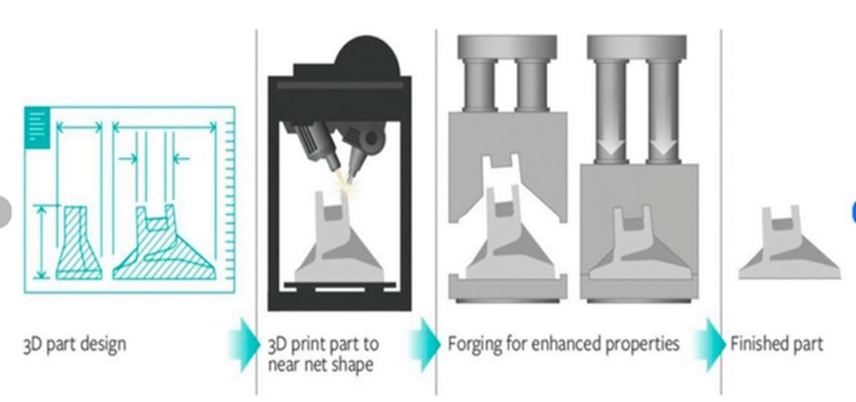
Source: Fabbaloo, HFI

One of the most impactful has been its long-standing collaboration with Airbus, which began in April 2016 with an agreement to supply 3D printed titanium fuselage and engine pylon components for commercial aircraft. In September 2017, the collaboration reached a significant milestone with the first installation of a 3D printed titanium bracket on a series-production Airbus A350, marking a leap forward in the certification and use of metal additive parts in structural applications.

Figure: Titanium 3D printed bracket
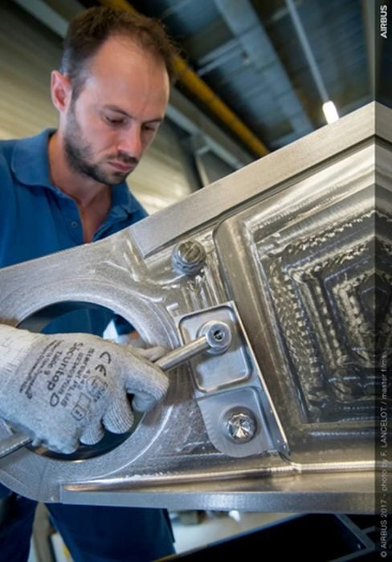
Source: Fabbaloo, HFI

Howmet Aerospace has firmly established itself as a global leader in two of the most critical areas of metal additive manufacturing: titanium alloy components and turbine blade production. According to a 2024 report by GlobalData, Howmet holds the top global position in patent filings related to titanium alloy 3D printing for the aerospace and defense industries, ahead of major players such as Boeing, RTX, and Safran.
Figure: Leaders in titanium alloy 3D printing
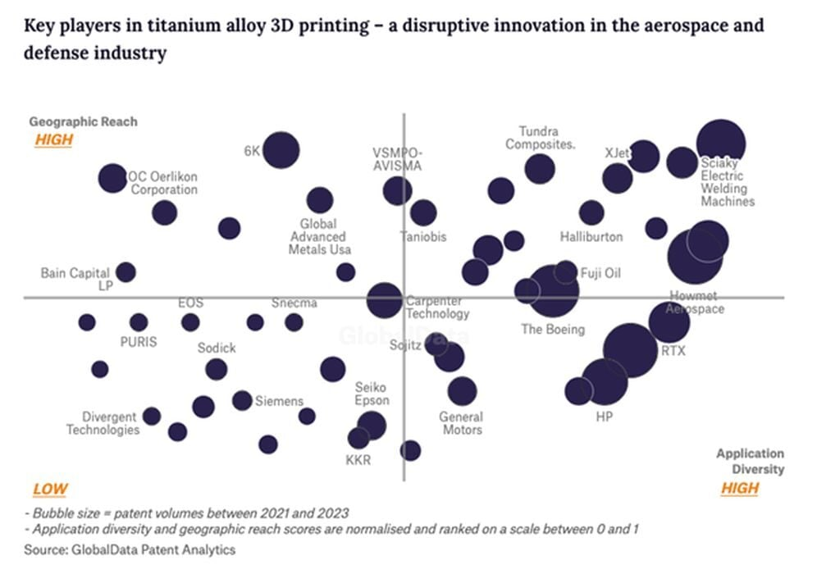
Source: Fabbaloo, HFI

Optimized 3D-printed hinge for deployment of spacecraft solar arrays whose nature-inspired design minimizes the amount of material and weight of the part – critically important for space travel.
Figure: Optimized 3D-printed hinge
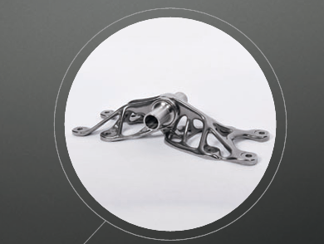
Source: Fabbaloo, HFI *Howmet's Engine Products business inherited the complete technical lineage of Arconic's former aerospace division.

2.3 Robust Order Book & Acquire CAM
Aerospace’s largest and fastest growing market is aerospace, where we have had a major presence since the Wright brothers’ first flight. Fueled by an expanding middle class and increasing air travel, global aircraft demand has led a firm order book with an 8.5 year backlog for both commercial aircraft and aero engines, and rising aircraft production by Boeing and Airbus, who are working to clear a global order book of over 17,000 aircraft.

Figure: Participation Across Airframe Platforms
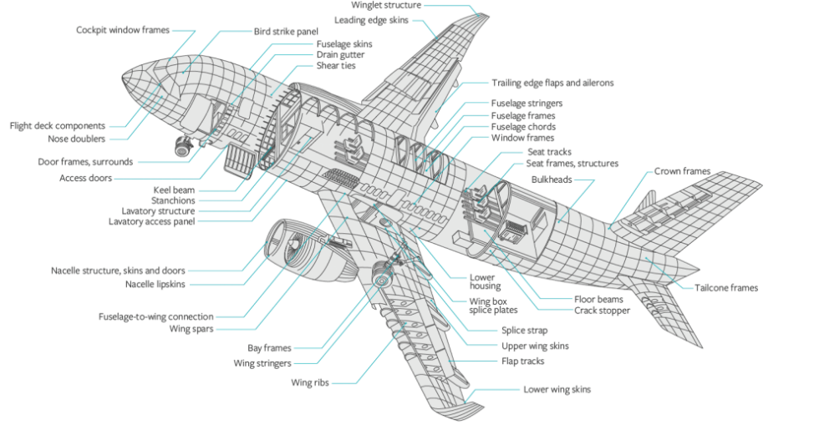
Source: Company Announcements, HFI

Boeing and Airbus are accelerating production to manage a record backlog exceeding 17,000 aircraft as of late 2025, with industry delivery times stretching up to 14 years. While Airbus targets 75 A320-family planes monthly by 2026, Boeing increased 737 Max production to 42 monthly in late 2025. Both face supply chain bottlenecks and skilled labor shortages.
Figure: Boeing & Airbus: 2025 Data Through Dec 31. (Backlog, Gross Orders and Deliveries)
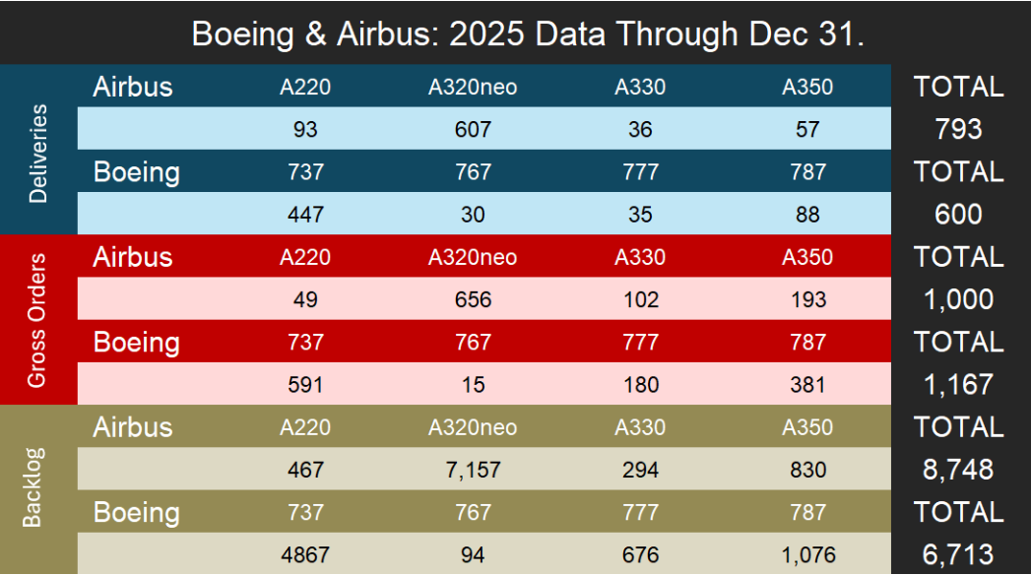
Source: Flightplan, HFI * A320neo numbers include all variants for the family; A319neo, A320neo and A321neo.

Figure: Narrow-Body & Wide-Body: Order & Deliveries in Dec 2025
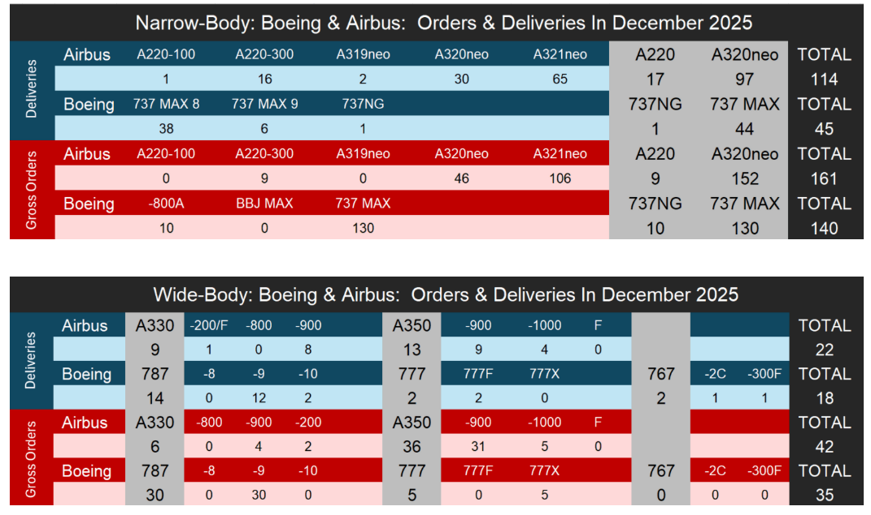
Source: Flightplan, HFI * A320neo numbers include all variants for the family; A319neo, A320neo and A321neo.

In Dec2025, Boeing handed over 63 jetliners to customers, bringing its annual delivery total to 600 aircraft, the most in seven years. Airbus delivered 793 commercial aircraft to 91 customers globally in 2025 and registered 1,000 new gross orders in the Commercial Aircraft business. The backlog at the end of December 2025 increased to a new year-end record of 8,754 aircraft highlighting the strong market demand for Airbus’ product portfolio.

Figure: Boeing airplane deliveries (2018-2025)
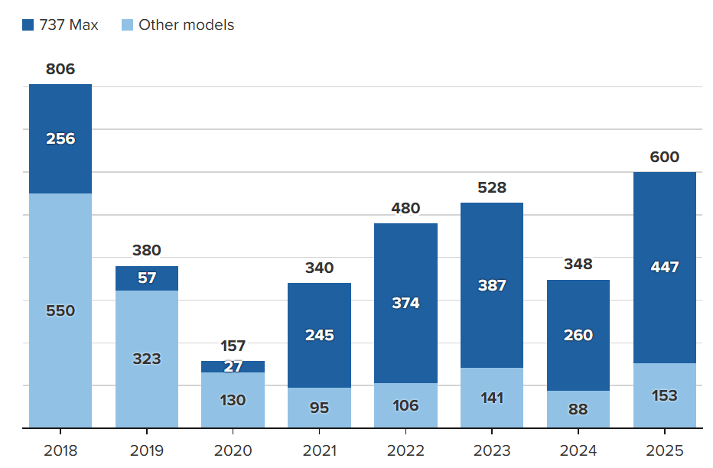
Source: Boeing, HFI

Figure: Airbus airplane deliveries (2023-2025)
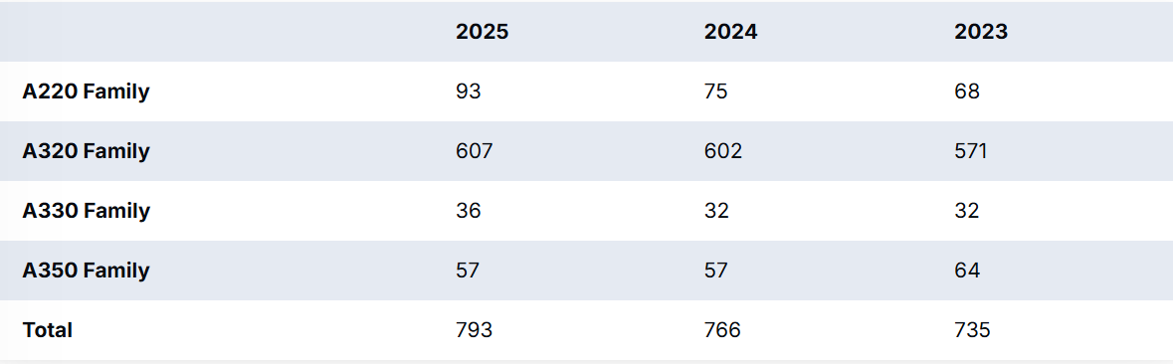
Source: Airbus, HFI

In 2026–2028, we forecast Airbus and Boeing MRO faces high demand driven by aging fleets, engine issues (specifically geared turbofan, or GTF), and a push to stabilize production rates. Airbus holds a structural advantage in narrowbody, while Boeing aims to reclaim market share through increased deliveries. MRO providers are focusing on capacity, with major component support deals already secured for 2026. MRO providers are rapidly expanding to handle increased, maintenance needs, with strong M&A activity expected in the sector.

CAM Acquisition Targets Aerospace Supply-Chain Pressure Points. Howmet Aerospace is making a big bet on the nuts and bolts of aerospace manufacturing. The company has agreed to acquire Consolidated Aerospace Manufacturing, or CAM, in an all-cash deal valued at roughly $1.8 billion, buying the business from Stanley Black & Decker.

CAM’s hardware is everywhere across modern aircraft and defense platforms. The company designs and manufactures precision fasteners, fluid fittings, latches, and other highly engineered components that are essential to keeping aircraft structures, engines, and systems together under extreme conditions. Its portfolio includes well-known aerospace brands such as Bristol Industries, 3V Fasteners, Moeller, Aerofit, Voss Industries, QRP, E.A. Patten, and Prikos & Becker.

Figure: CAM hardware touches everything from the 737 MAX and A350 to the F-35 and KC-46

Source: Flightplan, HFI

In commercial aviation, CAM supplies high-strength fasteners, specialized latches, and ducting components used on major Boeing programs, including the 737 MAX and 787 Dreamliner. It is also a key supplier to Airbus, providing mission-critical latches and fluid fittings for the A320neo family, as well as widebody platforms such as the A350 and A330. Beyond large commercial jets, CAM hardware appears on aircraft produced by regional and business jet manufacturers, including Bombardier and Embraer.

The defense side of the business is equally broad. CAM components are integrated into frontline fighter aircraft such as the F-35 Lightning II, the F-15 Eagle, and the F/A-18 Super Hornet, where reliability under heat, vibration, and combat stress is non-negotiable. The company also supplies airframe hardware for heavy transport and tanker aircraft, including the C-17 Globemaster III and the KC-46, and produces components for military helicopters built by Bell and Sikorsky.

CAM’s reach extends into propulsion as well. The company provides tubular assemblies and fittings used in major engine programs, including GE Aerospace’s GEnx and LEAP engines, Pratt & Whitney’s Geared Turbofan, and Rolls-Royce’s Trent family. It also supports space and strategic systems markets, supplying fluid distribution systems and high-pressure fittings for commercial launch vehicles and missile defense applications.

Howmet sees CAM delivering $485–495 million in top-line and better than 20% adjusted EBITDA margin in 2026, even before cost synergies. After synergies and tax perks, the price tag works out to roughly 13× adjusted EBITDA. Slated to close in 1H 2026, the deal highlights the accelerating shake-up in aerospace supply chains, especially in lucrative niches like precision fasteners and fluid systems. By folding CAM into its portfolio, Howmet boosts its Tier-1 status with both commercial and defense primes, raising content per ship on virtually every major platform now rolling off the line. With build rates climbing and defense budgets staying flush, control of these hard-to-replace parts should give Howmet stronger pricing power, more resilient cash flows, and added leverage when negotiating with the industry’s biggest customers.

CAM Defense’s engineers have extensive expertise working with key new space firms such as Blue Origin, SpaceX, and Stratolaunch. They are on the cutting edge of contemporary liquid rocket technology, rapid and low-cost development programs, and DMLS 3D printing
Figure: CAM Defense - Propulsion

Source: CAMG, HFI

3. Industry Tailwinds & HWM Positioning
Howmet Aerospace's market position is characterized by its deep integration into the supply chains of leading aerospace and defense original equipment manufacturers (OEMs). By focusing on high-value, highly engineered engine and airframe components, it erects steep barriers for would-be rivals. Repeated on-time delivery of complex parts that meet exacting quality specs cements this advantage. Long-standing co-development agreements with Rolls-Royce, Boeing, Airbus and Lockheed Martin lock in share on critical platforms, while continued investment in advanced manufacturing and materials science widens the moat.

3.1 Solid Demand in Defense Aerospace
For over 40 years, Howmet Aerospace has been a key defense manufacturing partner to the U.S. military and allied nations. In collaboration with prime contractors, their products support systems across the air, sea and ground-based radar and aerospace markets.

Figure: Photo courtesy of U.S. Navy
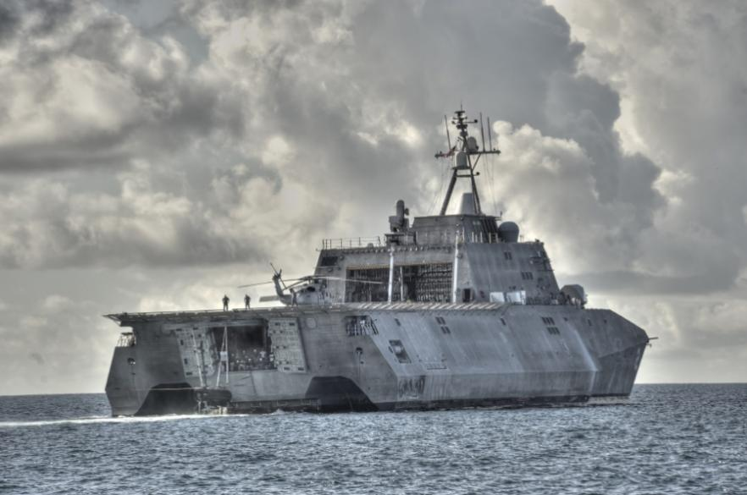
Source: Howmet website, HFI

In July 2025, the House of Representatives passed the fiscal year 2026 Defense Appropriations Act, providing a strong budgetary allocation for defense. Defense aerospace again outperformed, posting 21 % top-line growth in Q2 on spare-engine demand for the F-35 and legacy fighter fleets. Washington’s newly approved $831.5 bn FY-26 defense appropriation gives HWM a clear runway to win follow-on orders and push its defense sales—today 17 % of the total—even higher.

European Union defense spending is experiencing an unprecedented surge, with expenditures estimated to reach €381 billion in 2025, a 62.8% increase since 2020, representing 2.1% of EU GDP. Driven by the need for strategic autonomy and support for Ukraine, the EU aims to mobilize €800 billion for defense, pushing for 55% of military purchases to be made in Europe by 2030.

Figure: European Defence Spending on the rise
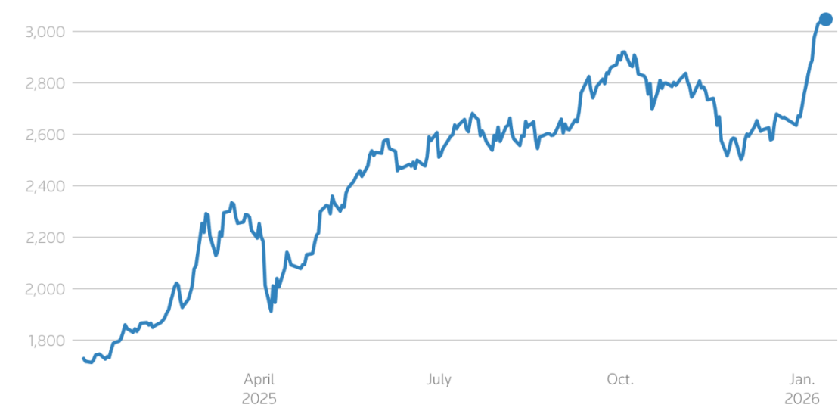
Source: LSEG Workspace, HFI

3.2 Advanced Manufacturing & Powering Deep Space exploration
Howmet isn’t a single widget; it’s an integrated toolbox of turbine parts, fastening systems, aero castings, forged wheels and high-temperature alloys that solve the nastiest stress, heat and load problems in modern transport. Its parts sit deep inside next-gen narrow-bodies, fighter jets, rocket motors, EVs, heavy trucks and industrial turbines.
The portfolio is planted squarely at the intersection of three long-wave drivers:
Aero refresh and up-gauging – airlines are dumping older airframes for lighter, more efficient models stuffed with composites and advanced powerplants that need precisely what Howmet makes.
Decarbonization and fuel thrift – every kilo and every 0.1 % of engine efficiency counts; the company sells the metal-working blocks that deliver those savings.
Surging defense and space budgets – missiles, hypersonic and reusable launchers demand exotic alloys and zero-fail precision parts, a sweet spot Howmet already supplies.

4. Valuation& recommendation
We estimate that revenue of HWM from year 2025 to 2028 will be $8,188/9,106 /10,077/11,139 million, with the net profit of $1,408/1,711/1,883/2,190million. Based on the DCF valuation model, our target price of HWM is $234.72, we initiate coverage on the stock with “Outperform”.

Table: DCF Model
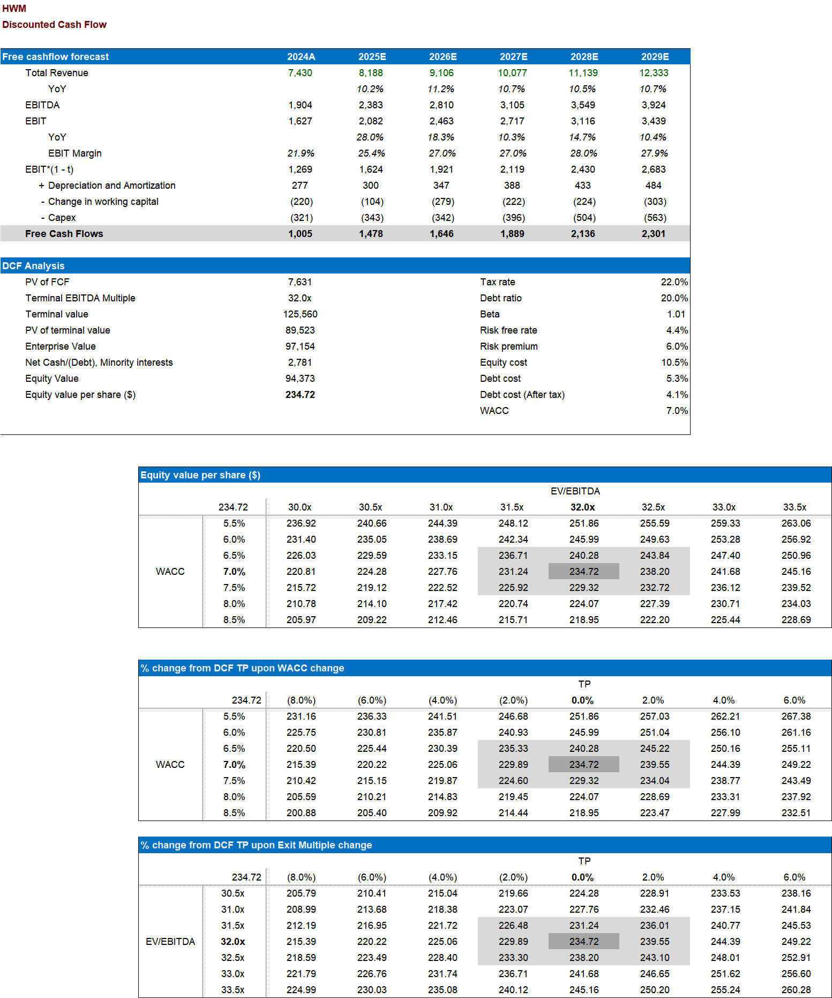

Source: Company Announcements, HFI

Table: Financial Summary
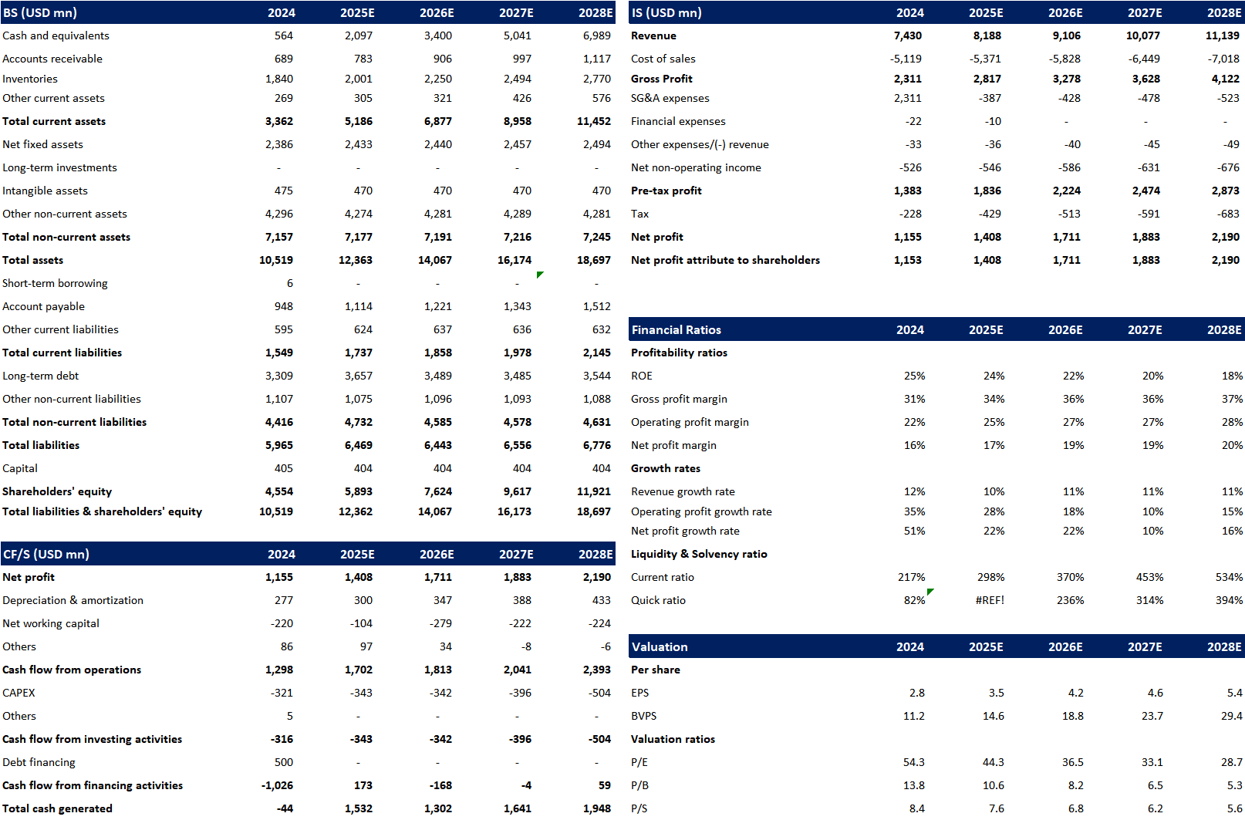
Source: Company Announcements, HFI

5. Risks
Market Demand & Economic Sensitivity; Narrow and Wide-Body Aircraft Market Risks Constraints in the supply chain, including shortages of engine components and labor; The cost of acquiring and integrating CAM may exceed the budget, affecting EBITA; Labor Negotiations and Workforce Challenges.

[Table_APPENDIX]
[Table_disclaimer]
APPENDIX
IMPORTANT DISCLOSURES
This research report is distributed by HuaFu International (HK) Financial Holdings Limited (referred as HuaFu International below), which is authorized to engage in securities activities in its respective jurisdiction.
Analyst Certification:
I, Bin Yang, certify that (i) the views expressed in this research report accurately reflect my personal views about any or all of the subject companies or issuers referred to in this research and (ii) no part of my compensation was, is or will be directly or indirectly related to the specific recommendations or views expressed in this research report; and that I (including members of my household) have no financial interest in the security or securities of the subject companies discussed.
Conflict of Interest Disclosures
HuaFu International and some of its affiliates may engage in investment banking and / or serve as a market maker or hold proprietary trading positions of certain stocks or companies in this research report. As far as this research report is concerned, please send an email to lcd@hfisec.com.hk if the information about any company mentioned in this report is needed).
Ratings Definitions (from 1 Jul 2020):
HuaFu International uses a relative rating system using Outperform, Neutral, or Underperform for recommending the stocks we cover to investors. Investors should carefully read the definitions of all ratings used in HuaFu International Research. In addition, since HuaFu International Research contains more complete information concerning the analyst's views, investors should carefully read HuaFu International Research, in its entirety, and not infer the contents from the rating alone. In any case, ratings (or research) should not be used or relied upon as investment advice. An investor's decision to buy or sell a stock should depend on individual circumstances (such as the investor's existing holdings) and other considerations.
Analyst Stock Ratings
Outperform: The stock’s total return over the next 12-18 months is expected to exceed the return of its relevant broad market benchmark by over 10%, as indicated below.
Neutral: The stock’s total return over the next 12-18 months is expected to be in line with the return of its relevant broad market benchmark, as indicated below. Underperform: The stock’s total return over the next 12-18 months is expected to be below the return of its relevant broad market benchmark by over 10%, as indicated below.
Benchmarks for each stock’s listed region are as follows: Japan – TOPIX, Korea – KOSPI, Taiwan – TAIEX, India – Nifty100, US – SP500; for all other China-concept stocks – MSCI China.

HuaFu International Non-Rated Research: HuaFu International publishes quantitative, screening or short reports which may rank stocks according to valuation and other metrics or may suggest prices based on possible valuation multiples. Such rankings or suggested prices do not purport to be stock ratings or target prices or fundamental values and are for information only.
HuaFu International Coverage of A-Shares: HuaFu International may cover and rate A-Shares . HuaFu Securities, the ultimate parent company of HuaFu International based in FuZhou, covers and publishes research on these same A-Shares for distribution in mainland China. However, the rating system employed by HuaFu International differs from that used by HuaFu Securites and even the teams covering the same A-share stocks might be totally independently different, as a result there may be a difference in their coverage ratings, target prices and research logics for the same A-share stocks.
IMPORTANT DISCLAIMER
The research report is issued by HuaFu International, a licensed corporation to carry on Type 4 regulated activity (advising on securities) for the purpose of the Securities and Futures Ordinance (Cap. 571) of Hong Kong.
The information and opinions contained in this research report have been compiled or arrived at from sources believed to be reliable and in good faith but no representation or warranty, express or implied, is made by HuaFu International or any other related members from which this research report may be received, as to their accuracy, completeness or correctness. All opinions expressed herein are as of the date of this research report and are subject to change without notice. This research report is for information purpose only. Descriptions of any companies or their securities mentioned herein are not intended to be complete and this research report is not, and should not be construed expressly or impliedly as, an offer to buy or sell securities. The securities referred to in this research report may not be eligible for purchase or sale in some jurisdictions. If an investment product is denominated in a currency other than an investor's home currency, a change in exchange rates may adversely affect the investment. Past performance is not necessarily indicative of future results. Certain transactions, including those involving derivatives, give rise to substantial risk and are not suitable for all investors. You should also bear in mind that recommendations in this research report are not tailor-made for you. The analyst has not taken into account your unique financial circumstances, such as your financial situation and risk appetite. You must, therefore, analyze and should, where applicable, consult your own legal, tax, accounting, financial and other professional advisers to evaluate whether the recommendations suits you before investment. Neither HuaFu International nor any of its directors, employees or agents accepts any liability whatsoever for any direct or consequential loss arising from any use of the materials contained in this research report.
HuaFu International and its affiliates, officers, directors, and employees, excluding the analysts responsible for the content of this document, will from time to time have long or short positions in, act as principal in, and buy or sell, the securities or derivatives, if any, referred to in this research report. Sales, traders, and other professionals of HuaFu International may provide oral or written market commentary or trading strategies to the relevant clients and the companies within HuaFu International that reflect opinions that are contrary to the opinions expressed in this research report. HuaFu Internatioal may make investment decisions that are inconsistent with the recommendations or views expressed in this research report. HuaFu International is under no obligation to ensure that such other trading decisions, ideas or recommendations are brought to the attention of any recipient of this research report.
Please refer to HuaFu International’s website www.hfisec.com.hk for further information on HuaFu International’s organizational and administrative arrangements set up for the prevention and avoidance of conflicts of interest with respect to Research.

DISTRIBUTION AND REGIONAL NOTICES
Except as otherwise indicated below, any Recipient wishing to discuss this research report or effect any transaction in any security discussed in HuaFu International’s research should contact the HuaFu International salesperson in their own country or region.
Notice to Hong Kong investors: The research report is distributed by HuaFu International, which is a licensed corporation to carry on Type 1 regulated activity (dealing in securities) in Hong Kong. This research report does not constitute a solicitation or an offer of securities or an invitation to the public within the meaning of the SFO. This research report is only to be circulated to "Professional Investors" as defined in the SFO. This research report has not been reviewed by the Securities and Futures Commission. You should not make investment decisions solely on the basis of the information contained in this research report. Recipients of this research report are to contact HuaFu International salespersons in respect of any matters arising from, or in connection with, the research report.

People’s Republic of China (PRC): In the PRC, the research report is directed for the sole use of those who receive the research report in accordance with the applicable PRC laws and regulations. Further, the information on the research report does not constitute "production and business activities in the PRC" under relevant PRC laws. This research report does not constitute a public offer of the security, whether by sale or subscription, in the PRC. Further, no legal or natural persons of the PRC may directly or indirectly purchase any of the security or any beneficial interest therein without obtaining all prior PRC government approvals or licenses that are required, whether statutorily or otherwise. Persons who come into possession of this research are required to observe these restrictions.
This research report is intended for the recipients only and may not be reproduced or redistributed without the written consent of an authorized signatory of HuaFu International.
Copyright: HuaFu International 2025. All rights reserved

[Table_RecommendationChart]

